

4 bedroom 3.5 bathrooms with seven bathroom sinks

3000 to 3100 feet of heated livable space

Stunning upgrades throughout this home

The outdoor living space is amazing. 30'X12' with a two story deck and plenty of privacy.

The home backs up to a common area with a beautiful waterfall.

Enjoy this premium home lot.

Extra-large lockable walk-in crawl space under home for storage

Pull down ladder for third storage area above upstairs bedrooms

Massive storage space above three car garages.

Brazilian cherry hardwoods in Master and main floor of the home

Stainless steel appliances

Open flowing floor plan with high ceilings.

P1: 704.609.9699
P2: 704.609.9698
E: friends@gregbeckerrealty.com

A: 5358 Cambridge Bay Dr.
Charlotte, NC 28269

W: www.gregbeckerrealty.com
Things to know
This home was built in 2000 by New Mark Homes. This may be the only model of its kind in Highland Creek.
Before the house hits the MLS you can schedule an appointment by calling Greg or Kristy and (704) 609 9699 or sending an e-mail to friends@gregbeckerrealty.com

http://www.gregbeckerrealty.com/listing/
Over 3000 feet of heated livable space
This home is being sold with a home buyers warranty by the owner who is a realtor broker

For Sale

5358 Cambridge bay Dr. Charlotte, NC 28269
$280,000

Choose your new neighbor!

Call (704) 609 9699

Tell a Friend, if they let us represent them on the purchase we will put hundreds in your pocket.

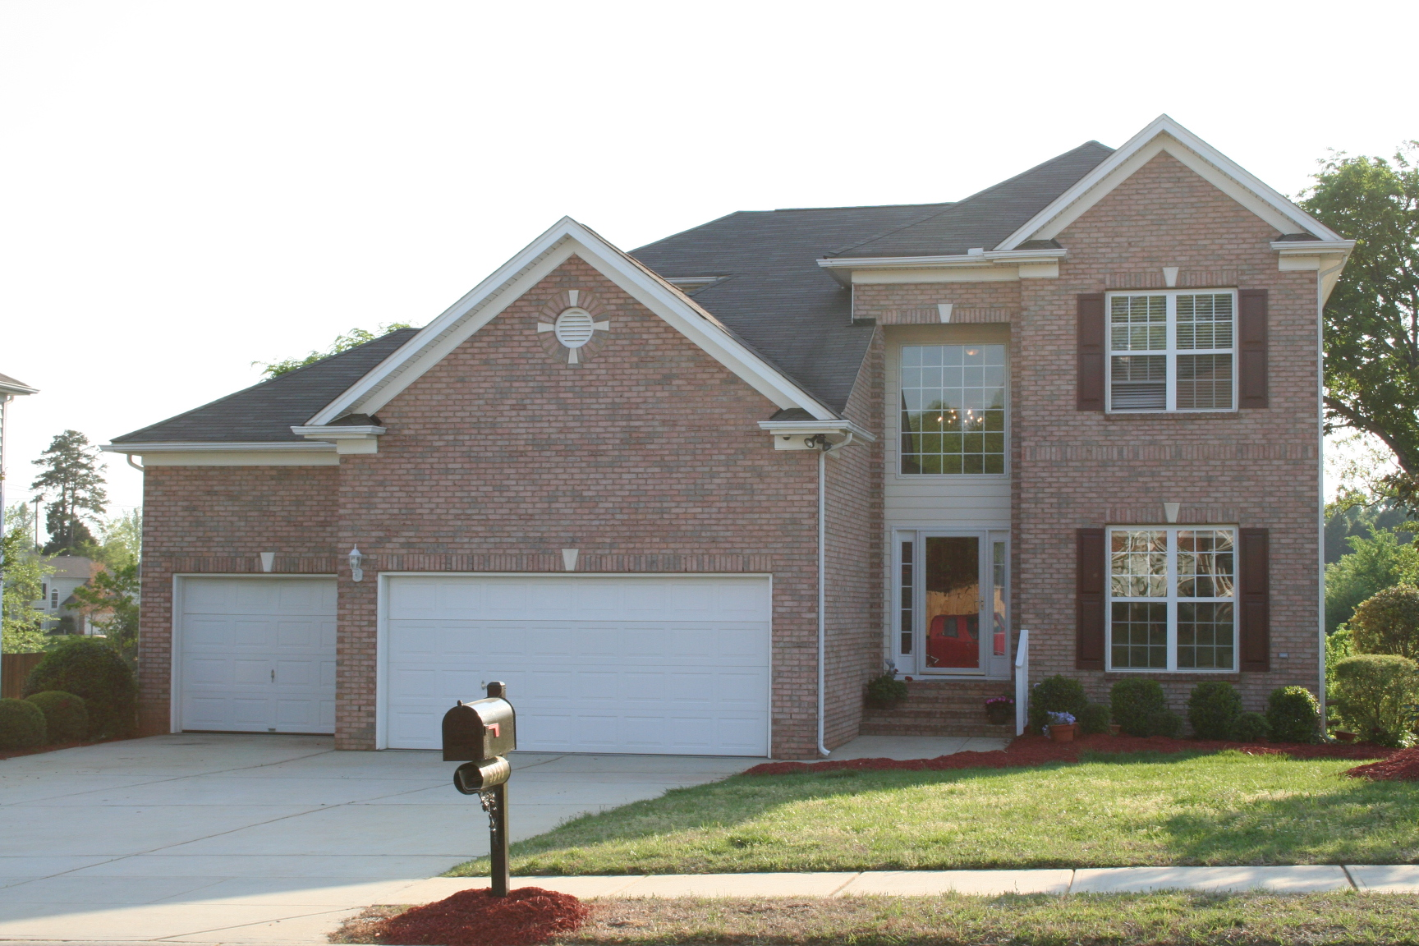
Quotes on the home:
“The extra storage space in your home is amazing"
"You guys really went all out"
"I love your kitchen granite and countertops"
"Your house has great bones"
“We really love what you've done to the backyard"
"I wish I could do that to my deck"
"What I would do to have those oversized three car garages"
"Your hardwoods really help with allergies"
"I love the view from your kitchen"
"I'd live on your deck"
"The potential for your house is in endless"

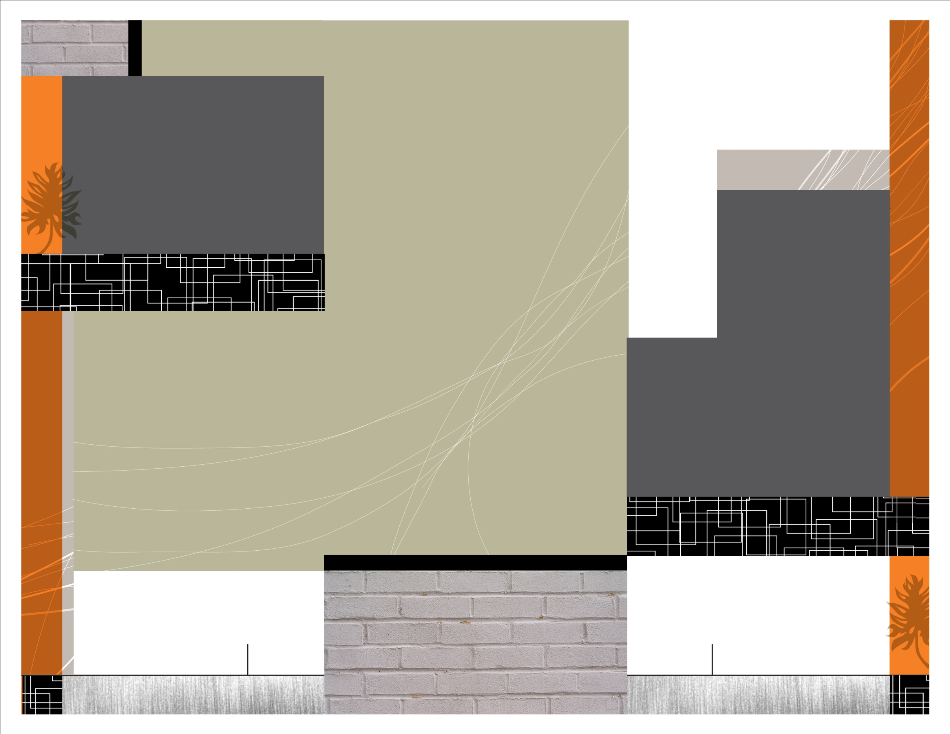
List of upgrade
Downstairs or Main floor
- Large walk-in kitchen pantry
- Storm doors in front and rear of house
- Master bathroom has separate vanities (his and hers)
- Granite countertops and new cabinets in kitchen
- His and her wall mounted bedroom reading lights on switches with dimmers. One for each side of the bed.
- Added ceiling fans and dimmer lights
- Glass top stove, and wall-mounted convection oven.
Upstairs
Bedroom and hall way light switches all turn on overhead lights (not just an a/c outlet)
Added ceiling fans and dimmer lights
Separate vanities (his and hers) in Jack and Jill bathroom – plus non-shared vanity in one room.
Potential fourth storage area in the upstairs bathroom
Outside
Large flat fenced yard. Landscaped to enjoy
Motion Sensor flood lights in front and rear

The fence around the house can open and allow a pickup truck into the backyard. The fence can also be locked.
Things to know:
• Laundry areas both upstairs and down.
• That view! That view! Ohh that view!!
• The house backs up to a common area.
• Professionally landscaped yard with a retaining wall separating the rest area from the play area.
• Video security cameras secure the home
• Pre-Wired Security system – that can be activated remotely
• Security panels in master bedroom and near garage.
• Electrical outlets added to deck and porch area under deck and front of house
• Prewired 220 for your hot tub ibackreahouse
•

•

.

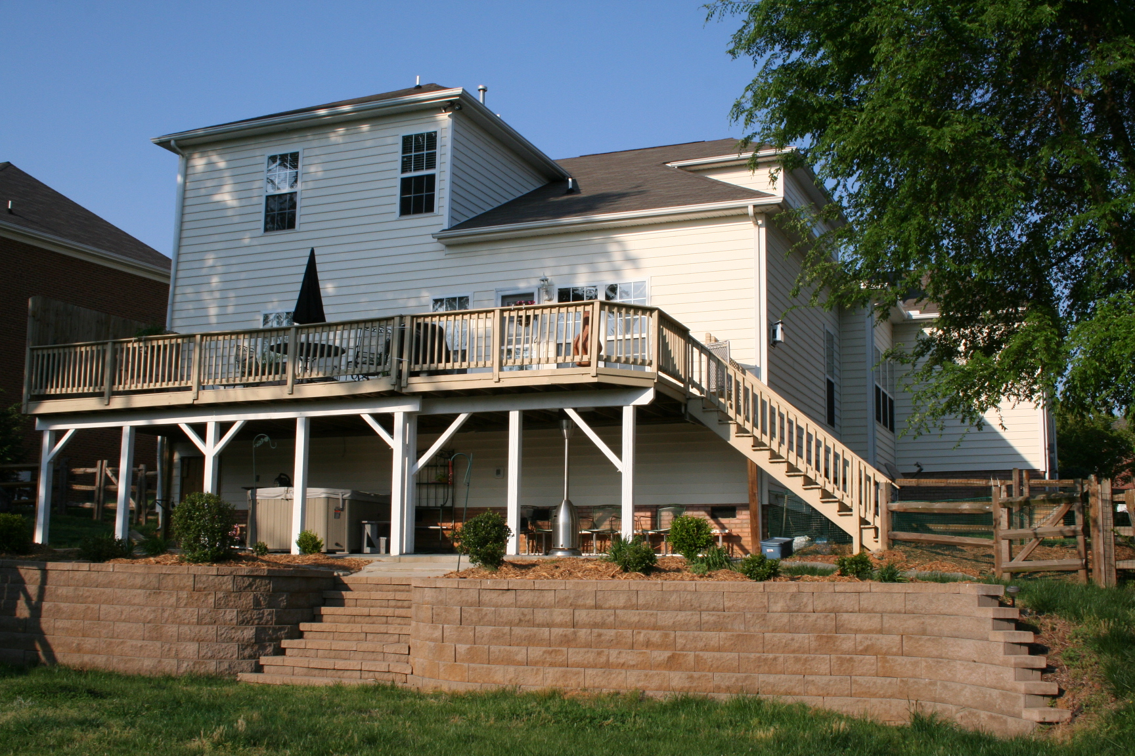

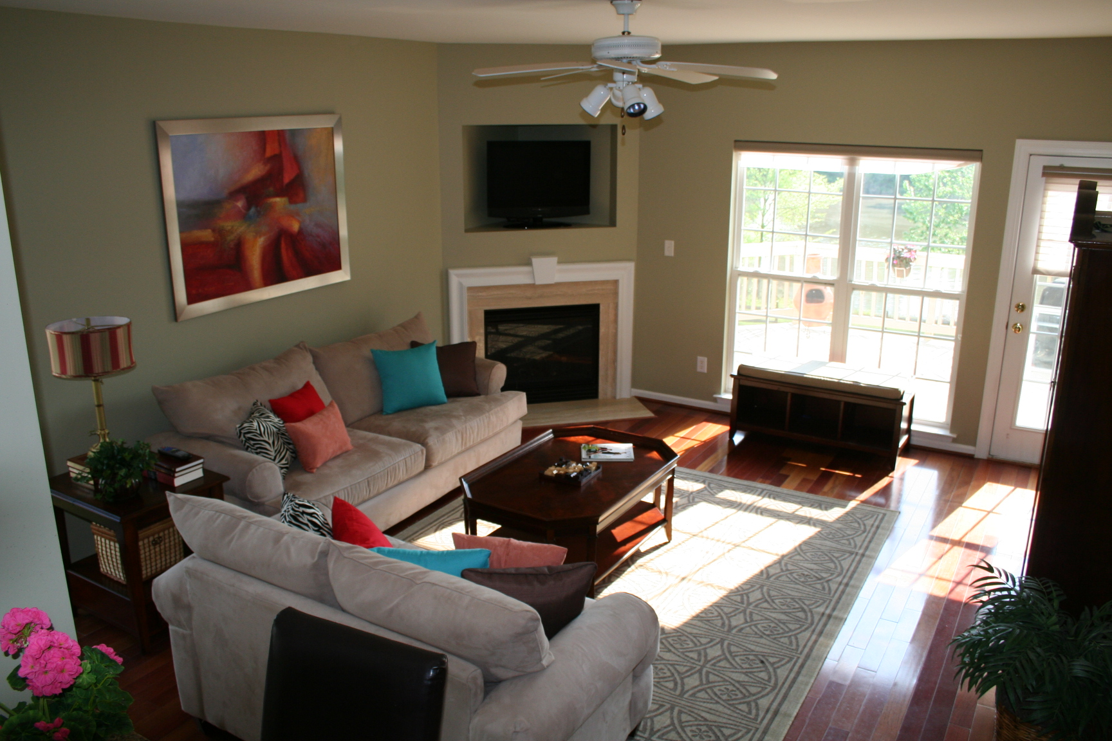
The living room

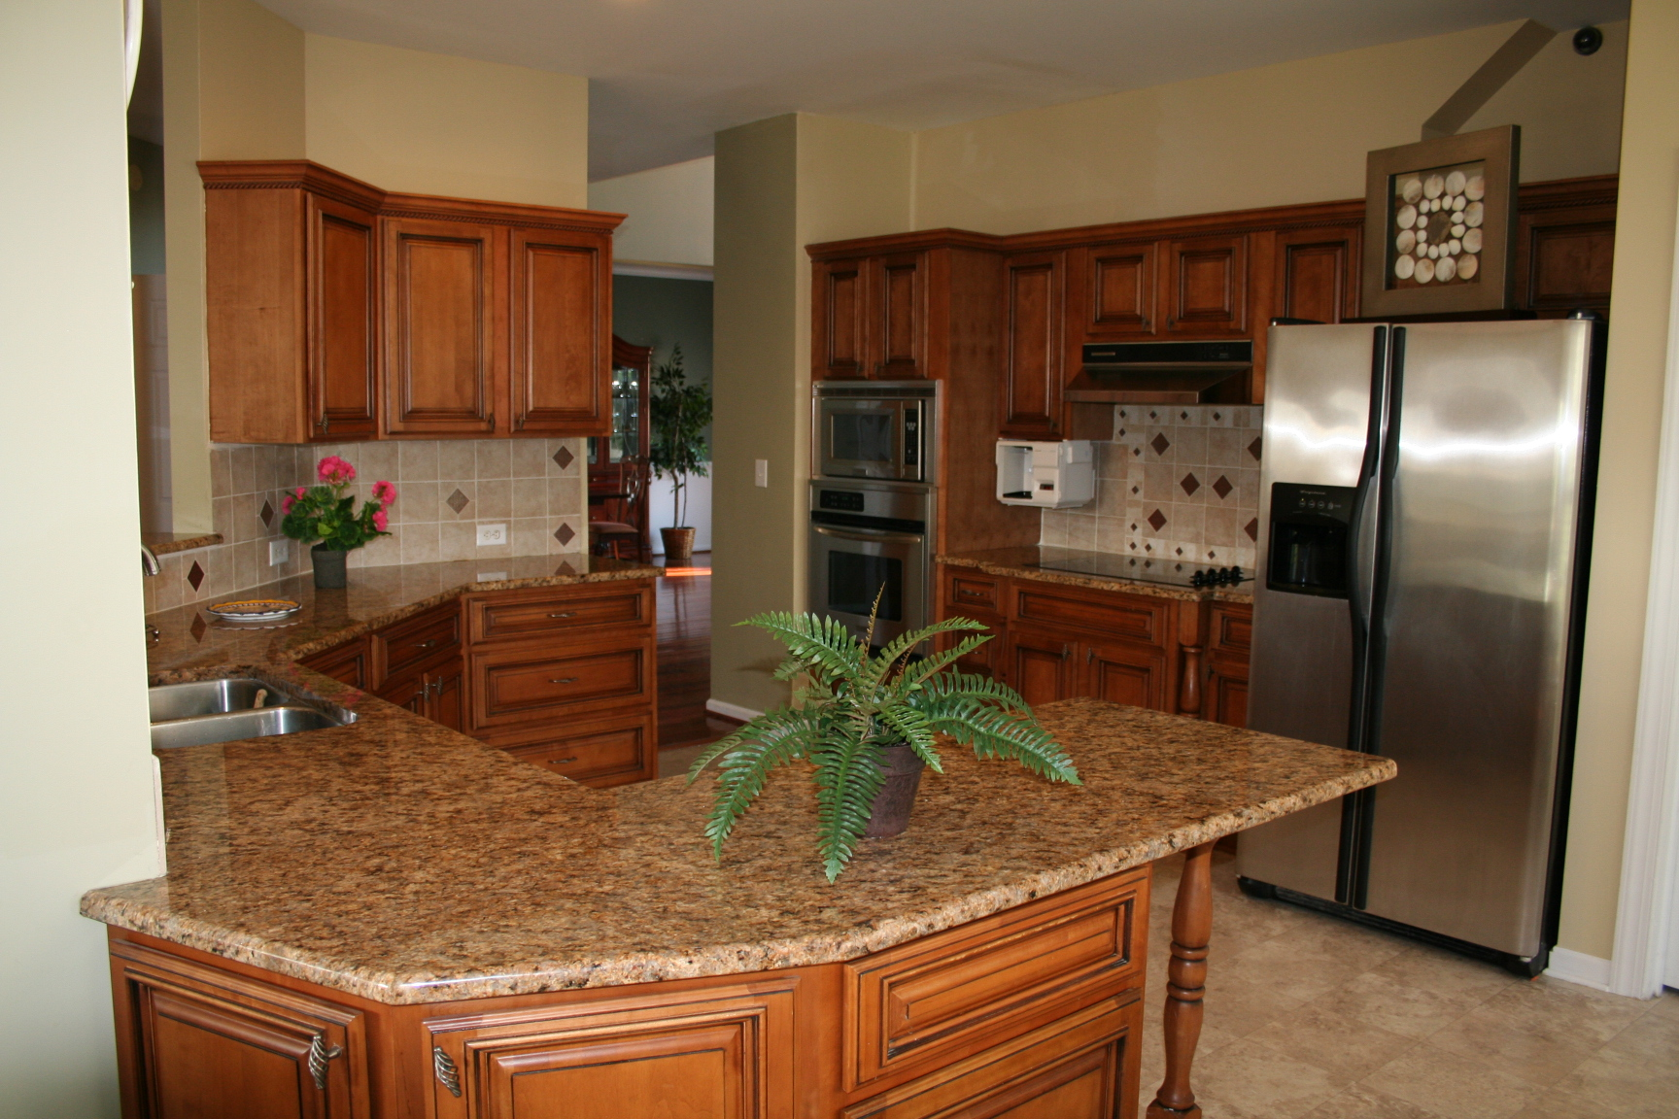
The kitchen

Delete box or place real
estate logos here

